2021 Quarterly Local Program Activity Overview
Submit with each quarter’s Reinvestment Report

PROGRAM NAME:

______Mineola Main Street_____

THIS REPORT COVERS:
☒ QUARTER 1 (covering January-March, due April 10th)
☐ QUARTER 2 (covering April-June 2020, due July 10th)
☐ QUARTER 3 (covering July-September, due October 10th)
(Your QUARTER 4 Activity will be part of the annual report/ Community Accreditation Standards that will be due in December 2021.)

This Activity Report aligns with the national office’s new Community Accreditation Standards (the former 10 Criteria), which Main Street communities nationwide will now submit to their coordinating programs as the annual report at the end of each year. That evaluation is now a strong component of determining National Accreditation. Using this activity template, local programs should briefly summarize activity as they relate to the revised standards, which outline general guidelines for performance:
1. Broad‐based Community Commitment
2. Leadership & Organizational Capacity
3. Diverse and Sustainable Funding
4. Strategy‐Driven Programming (Community Transformation Strategies)
5. Preservation‐Based Economic Development
6. Demonstrated Impact & Result
Using this new Quarterly Activity template, you should be able to more efficiently and effectively complete the annual self-evaluation (to be distributed in late fall 2020). Completion of these quarterly activity reports, and the annual report, should be a joint effort of both staff and board. This template should not just list activities or board/staff meetings; it should show how the program’s work/activities in its plan of work drives strategies and alignment with the standards (or working toward that). For those that have not yet adopted transformation strategies, this report should help in that process. Regardless of your program structure or process (i.e. traditional committees, task forces etc.) evidence that your program adheres to the Main Street Four Point Approach™ should be evident, as this remains the foundation of our work and the nationwide success of the Main Street movement.
https://www.mainstreet.org/mainstreetamerica/theapproach
“The Main Street Approach is centered around Transformation Strategies. A Transformation Strategy articulates a focused, deliberate path to revitalizing or strengthening a downtown or commercial district’s economy.”

We have adopted and articulated our Main Street Transformation Strategy or strategies ☒Yes ☐ No
Please summarize your strategy or strategies:
We are currently focused on fundraising to help our current and new businesses make improvements in our Main Street District.

Our work is completed through: _____ Traditional four-point committee model _____ Task forces/Project committees
___x_Other _____ Combination

Please provide a brief description of activity below. Add summaries, images, sample media coverage etc. on an extra page(s) to further describe activities if needed. (not required).

ECONOMIC VITALITY
Focuses on capital, incentives, and other economic and financial tools to assist new and existing businesses, catalyze property development, and create a supportive environment for entrepreneurs and innovators that drive local economies | Our Main Street Board continues to consider and approve Main Street incentive grants assisting current and new businesses in improving the Main Street District. Our city’s economic developers regularly work to unite building owners with potential business owners looking for a location in our district. One new building owner told us that they had tried to buy three or four other buildings downtown before they were able to purchase the one they have recently bought. Despite the effects of Covid, progress is being made with our artisan pizza shop opening in a larger location soon, two small boutiques opening this spring and the prospect of our first candy store opening this year.

DESIGN
Please provide images/descriptions on separate pages for any physical improvements completed during the quarter (before/after). The data should also appear in your reinvestment reports.
Supports a community’s transformation by enhancing the physical and visual assets that set the commercial district apart. | Our historic preservation commission under the umbrella of Main Street, the Landmark Commission, considers all exterior alterations to structures in our Historic Overlay District, protecting our city’s image and historic integrity as much as possible. If approved by the Landmark Commission, then our Main Street Board reviews any changes and encourages positive improvements with the incentive grants.
PROMOTION
Positions the downtown or commercial district as the center of the community and hub of economic activity, while creating a positive image that showcases a community’s unique characteristics. | During the recent months, most promotion was done by our former Marketing Director Lynn Kitchens who placed advertising in local, regional and state media featuring the amenities of Mineola, including our downtown.

ORGANIZATION
Creates a strong foundation for a sustainable revitalization effort, including cultivating partnerships, community involvement, and resources for the district. | After the resignation of two Main Street Board members, including our president who was invited to serve on the most prestigious non-elected foundation in our town, our board has approved two new members who are eager to help our town. Our city provides a volunteer/board member application form on our website to help attract new members as well. Our local newspaper, radio station and Facebook news source provide fantastic coverage of any activities undertaken to support our Main Street Program.

Submit to: mainstreet-reports@thc.texas.gov
Thank you!

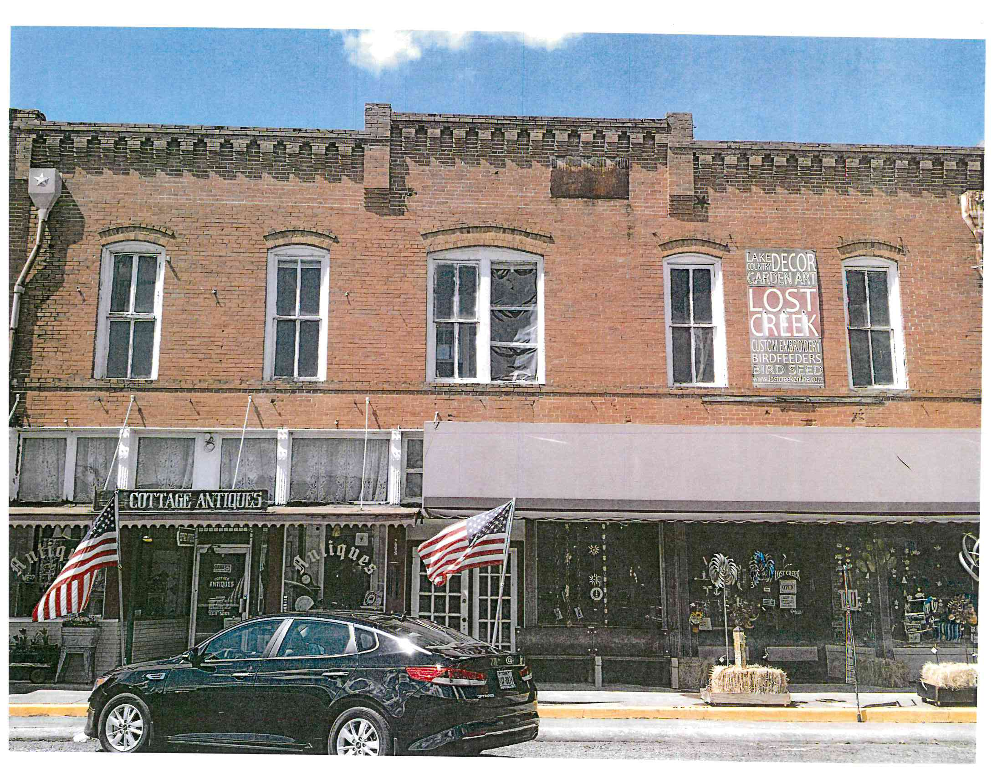
The building owner wanted to restore the old windows but told us they were unable to do so. Sections of panes of glass began to fall from the windows and even ripped the awning before the new windows were completed.
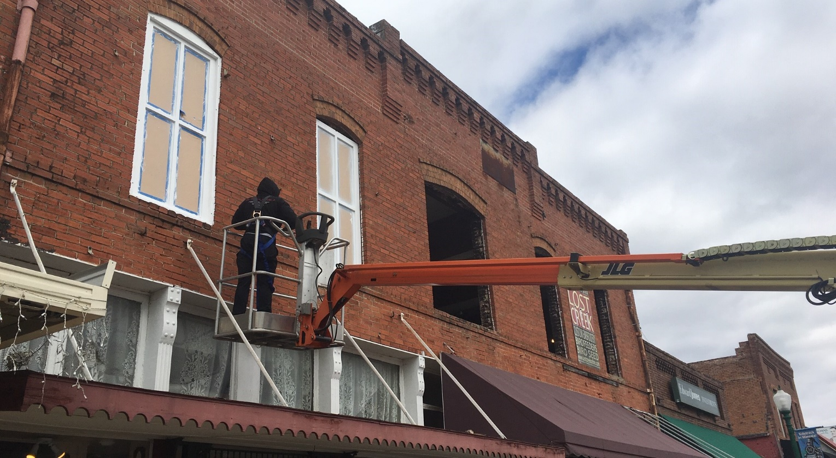
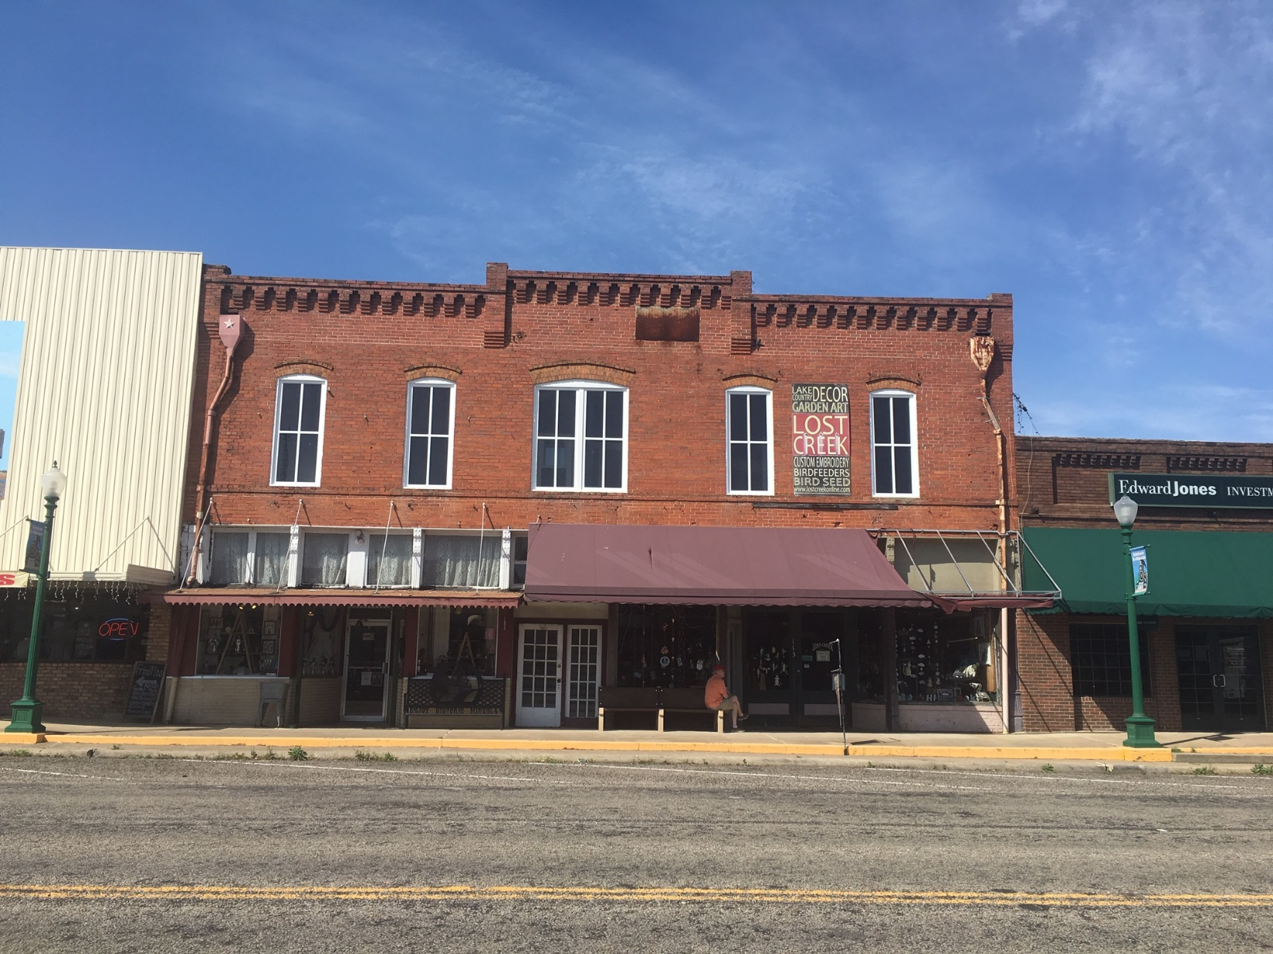
The finished product at 113 East Broad, for which an incentive grant was approved and issued by Main Street.

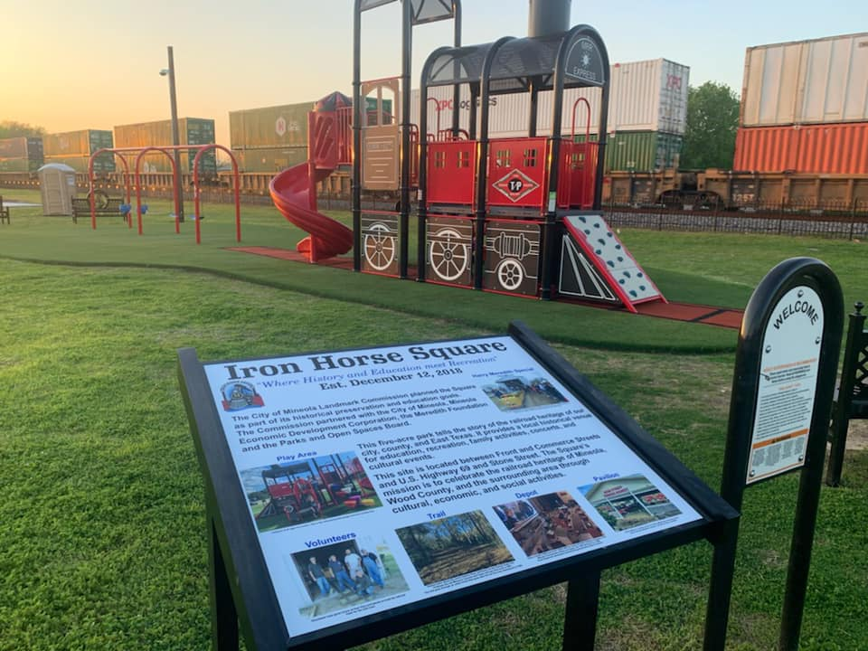

Funds from a grant from the county economic development commission paid for the Iron Horse Square introductory sign telling the story of the park’s reason for existence.
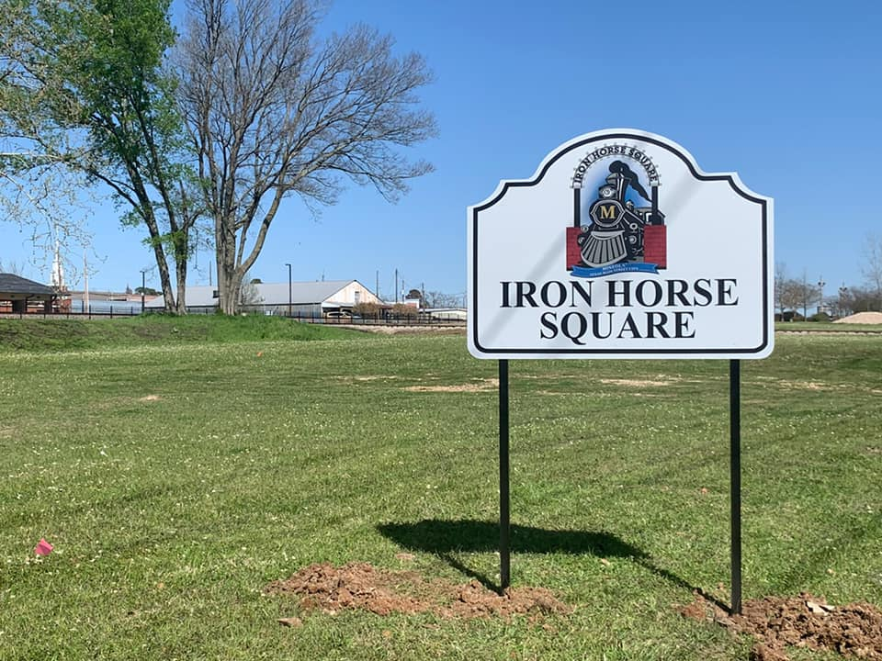

After highway signs were installed on the Highway 80 west entrance to downtown, our Landmark Commission decided the park property needed to be proclaimed on the west end of the property.

